**Assessing High-Resolution CubeSat Imagery and Machine Learning for Detailed, High Resolution Snow-Covered Area.** Anthony F. Cannistra, Nicoleta Cristea.

**Section X:** Results

Here we divide the evaluation of our snow classification model into three assessment frames. We first show that a model fitted with data from the Upper Tuolumne Basin, California, USA (see Section X) produces snow classifications in alignment with other state of the art snow observing methods when assessed using out-of-sample data also from Tuolumne. Second, we find comparable performance when assessing the same model (fitted with Tuolumne data) using out-of-basin data from the Gunnison River/East River Basin, Colorado USA (see Section X). Third, we show that our model has promise in its ability to fill temporal data gaps in other remotely-sensed snow cover products.

**X.1**: Classification Performance

**X.1.1**: Upper Tuolumne Basin, CA, USA

Coming soon.

**X.1.2**: Gunnison River Basin, CO, USA

We evaluate the out-of-basin model performance of the Tuolumne Basin snow classification model using a single Planet Labs, Inc imagery collection in the Upper Gunnison/East River Basin, Colorado, USA (Figure X2; Panel A. Image *20180524*_172637_0f2d), paired with a contemporaneous ASO collection (ASO/NSIDC ID: ASO_3M_SD_USCOGE_*20180524*). When comparing against binary ASO ground-truth snow cover, the out-of-basin model performs as well or better than two other comparably high resolution snow cover products (Landsat 8 fSCA and Sentinel-2 NDSI, see Section X) across all four computed classification metrics (Figure X1; red bars). 

**Figure X1:** Out-of-basin model performance of the Tuolumne Basin snow classification model in the Upper Gunnison/East River Basin, Colorado, USA (red bars) is as good or better than two other high-resolution snow cover data products (blue bars). These metrics are computed using ASO ground truth snow classification at ASO (3 meter) resolution (all products are interpolated to 3 meter resolution for comparison).

However, the Tuolumne model exhibits patterns of systematic misclassification in constrained geographic regions in the out-of-basin image sample (Figure X2, Panel D). In particular, the model fails to accurately identify snow-covered regions in low-elevation or densely forested regions (Figure X2; Panel D, red regions.). Smaller regions of inaccurate classification exist in rocky alpine areas, where the Tuolumne model misidentifies snow-free regions as snow-covered (Figure X2; Panel D, blue regions).

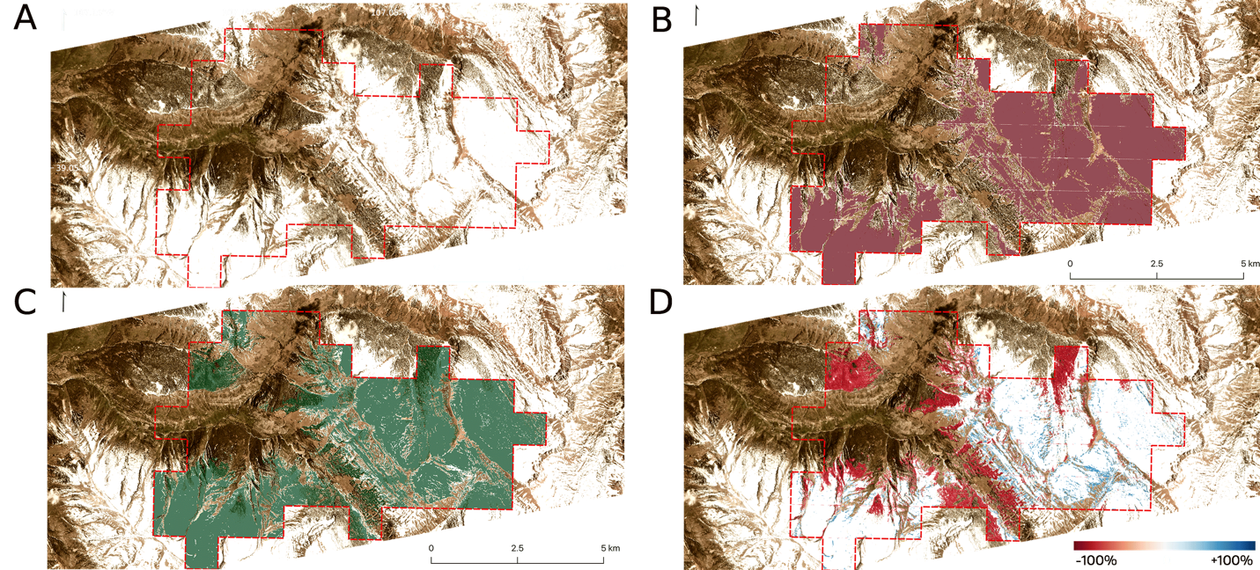

**Figure X2:** Results from a machine learning-based snow classification model (**B**) show both agreement and systematic divergence (**D**, Model – ASO difference map) from a contemporaneous Airborne Snow Observatory observation (**C**) in the Upper Gunnison River Basin, Colorado, USA (**A**). Red dotted line delineates region of overlapping data availability. Satellite imagery and ASO data acquired 24 May 2018 (Planet Labs, Inc. asset 20180524_172637_0f2d; ASO/NSIDC ID: ASO_3M_SD_USCOGE_20180524). Image assets are property of Planet Labs, Inc and are used with permission.

**X.2**: Temporal Gap-Filling

To evaluate the potential of this approach to fill observation gaps in other snow covered area products, we compare pixel-level difference from a coarser-resolution fSCA product (in this case Landsat 8) to both ASO-derived fSCA and model-derived fSCA. These fractional measures are computed by averaging the high-resolution binary product (ASO/model) to a coarser resolution matching the temporally-sparse data product being compared, see Methods. We find similar distributions of difference from ASO and our Tuolumne-trained model (mean differences of -24.00% and -15.40%, respectively; Figure X3, distributions). Landsat 8 demonstrates a more homogeneously negative skew when compared to ASO than the corresponding distribution between Landsat 8 and the model classifications (Figure X3, maps).



**Figure X3**: Similar Landsat 8 fSCA difference distributions exist between the Tuolumne-based model and ASO. Red regions are areas of Landsat 8 under-identification of snow relative to compared data, and blue regions are areas of Landsat 8 over-identification. Histograms demonstrate the distribution of pixels in each difference map. Data are compared at Landsat 8 resolution (30 meters).